Задание 1:

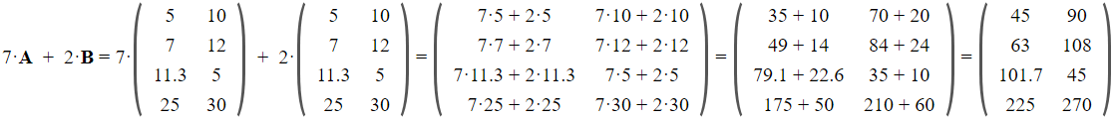

Задание 2.1:

3x – 2y + 5z = 7

7x + 4y – 8z = 3

5x – 3y – 4z = –12

3x + 5z - 7 = 2y

y = (3x + 5z - 7) / 2

7x + 2(3x + 5z - 7) – 8z = 3

5x – 1.5(3x + 5z - 7) – 4z = –12

13x + 2z -14 = 3

0,5х -11,5z + 10,5 = -12

13x + 2z = 17

0,5х -11,5z = -22,5

13x + 2z = 17

х - 23z = - 45

13x + 2z = 17

х = 23z - 45

13(23z – 45) + 2z = 17

299z – 585 + 2z = 17

**Ответ:**

z = 2

x = 1

y = 3

Линейная

Линейное

Задание 2.1:

x2 + y∙x – 9 = 0

x – y/5 = 0

5x = y

Xx + 5xx = 9

6xx = 9

**Ответ:**

Xx = 1,5

Y = ~6,1

Линейная

Первое нелинейное

Задание 3:

Система уравнений

X * Y = 48

2X + 2Y = 28

x = 48/y

2X + 2Y = 28

96 + 2yy = 28y

Yy – 14y = -48

**Ответ:**

Y1 = 6 X1 = 8

Y2 = 8 X2 = 6